MD2201: Data Science

Name of the student: Bhagwat Vinod Kolekar Roll No. 58

Div: ET-B Batch: B3

Date of performance:

Experiment No.5

Title: Classifier.
Aim: To apply Nearest Neighbor algorithm.

Software used: Programming language R.

Code Statement:
Consider 18 points data set referred in theory class. Consider test sample P(3,2). Apply following algorithms to find the class of this test point.
- NN
- KNN with K=5
- R-NN Radius based algorithm with radius as 1.45 units.

Code: (Write code for above statements here)

f1<-read.csv("knn1_csv.csv")
ed=sqrt((f1$x - 3)**2+(f1$y -2)**2)
f1<-cbind(f1,ed)
#print(f1)
#for sorts the index means gives the order by displaying index
order(f1$ed)
#for getting values in order
f1_sort<-f1[order(f1$ed),]
#print(f1_sort)

#1. NN algorithm
cat("class of P for NN is: ",f1_sort[1,4])

#2. KNN algorithm k=5
df1<-f1_sort[1:5,]
l1<-sum(df1$class==1)
l2<-sum(df1$class==2)
l3<-sum(df1$class==3)
if(l1>l2&l1>l3)
cat("\nclass of p for k=5 is: ",1)
if(l2>l1 & l2>l3)
cat("\nclass of p for k=5 is: ",2)

if(l3>l1 & l3>l2)
cat("\nclass of p for k=5 is: ",3)

#Radius based NN
df2<-f1_sort[f1_sort&ed<1.45,]
#print(df2)
l11<-sum(df1$class==1)
l21<-sum(df1$class==2)
l31<-sum(df1$class==3)
if(l11>l21&l1>l31)
cat("\nclass of p for rnn is: ",1)
if(l2>l11 & l21>l31)
cat("\nclass of p for rnn is: ",2)
if(l31>l11 & l31>l21)
cat("\nclass of p for rnn is: ",3)

Results: Display the output obtained on R console for all the cases.

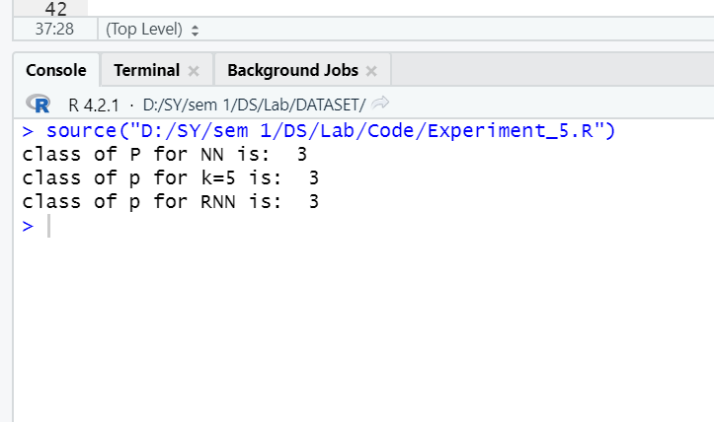

Conclusion: (Write the conclusion in your words. Write the answers to the questions asked in all the above code statements.)

- NN Algorithm –
One of the data points present in class 3 have the least Euclidean distance from point P, so according to the NN algorithm point, P must belong to class 3.

- KNN Algorithm –
According to this algorithm, the 3 data points which are having less Euclidean distance belong to class 3 so point P also belongs to class 3.

- RNN Algorithm –
Considering the radius = 1.45 and found that the maximum number of data points that come under this radius have class 3 so point P has class 3 according to this algorithm.

